PROJECT REPORT

Implement Client Script & UI Policy (Incident)
Team ID: SWTID-2026-1012
Team Size: 3
Team Leader: Raman P
Team Members: Sivasakthi P, Selvakannan C

1. Introduction

1.1 Project Overview
This project implements a UI Policy named 'High Impact Control' along with three Client Scripts (onChange, onSubmit, and onCellEdit) on the Incident table in ServiceNow. The objective is to make Assignment group mandatory and Urgency read-only (and auto-set) when Impact is High, enforce Assigned To as mandatory for High Impact incidents on submit, and prevent the State field from being changed directly through list-view inline editing.

1.2 Purpose
The purpose of this solution is to ensure every High Impact Incident is properly owned and correctly flagged, while protecting the integrity of the State field from uncontrolled list-view edits, thereby improving data quality, accountability, and incident resolution speed.

2. Ideation Phase

2.1 Problem Statement
PS | I am | I'm trying to | But | Because | Which makes me feel
PS-1 | A ServiceNow Incident support agent | make sure every High Impact incident has an owner and correct Urgency | I sometimes save High Impact incidents without an Assigned To or with the wrong Urgency | there's no automated validation enforcing Assigned To and Urgency when Impact = High | Frustrated and worried about unassigned critical incidents
PS-2 | A ServiceNow admin/team lead | protect the integrity of the State field on Incident records | agents sometimes change State directly from the list view without proper review | there's no restriction preventing inline State edits from the list | Concerned about uncontrolled status changes

2.2 Empathy Map Canvas
Section | Details
Think & Feel | Worried about missing Assigned To on High Impact incidents; frustrated by escalations without an owner
See | High Impact incidents unassigned; Urgency inconsistently set; State changed carelessly from list view
Hear | Manager insists High Impact incidents must have an owner and correct Urgency
Say & Do | Sets Impact quickly without always assigning an owner; edits State directly from list view sometimes
Pain | High Impact incidents saved without an assignee; State changed accidentally from list
Gain | Wants Assigned To enforced for High Impact; Urgency auto-updated; State changed only via form

2.3 Brainstorming
How might we ensure High Impact Incidents always have a mandatory owner and correct Urgency, while protecting the State field from uncontrolled list-view edits?
- Create UI Policy 'High Impact Control' to make Urgency read-only when Impact = High
- Add onChange Client Script to auto-set Urgency to High when Impact is High
- Add onSubmit Client Script to block save when Assigned To is empty for High Impact
- Add onCellEdit Client Script to block direct State field edits from the list view
Final Selected Approach: UI Policy 'High Impact Control' + three Client Scripts (onChange, onSubmit, onCellEdit).

3. Requirement Analysis

3.1 Customer Journey Map
Scenario: Agent creates and updates a High Impact Incident record. Steps flow from login -> setting Impact=High (Urgency auto-sets, becomes read-only) -> submitting (Assigned To checked) -> list view (State edit blocked).

3.2 Solution Requirement
Functional Requirements:
FR No. | Requirement (Epic) | Sub Requirement
FR-1 | UI Policy - High Impact Control | Condition: Impact = 1-High / Active = true / Reverse if false = true
FR-2 | UI Policy Action - Urgency | Urgency field Read-only when Impact = High
FR-3 | Client Script - onChange | Auto-set Urgency to High when Impact changes to High
FR-4 | Client Script - onSubmit | Block save if Assigned To empty when Impact = High
FR-5 | Client Script - onCellEdit | Block State field edit from Incident list view
Non-Functional Requirements:
NFR No. | Requirement | Description
NFR-1 | Usability | Error/alert messages must be clear and actionable
NFR-2 | Security | Only ITIL/incident_manager role can modify configuration
NFR-3 | Reliability | Validation consistent across change, submit, and list edit
NFR-4 | Performance | Scripts execute in real-time (<1 sec)
NFR-5 | Availability | Works across sessions without cache refresh
NFR-6 | Scalability | Pattern extends to other conditions/tables

3.3 Data Flow Diagram
Agent -> Incident Form -> High Impact Control UI Policy -> Client Script Engine (onChange/onSubmit) -> Incident Table (DB) -> List View -> onCellEdit Validation (State) -> Updated Record

3.4 Technology Stack
S.No | Component | Technology
1 | User Interface | ServiceNow UI (Now Platform)
2 | Declarative Logic | UI Policy 'High Impact Control' + UI Policy Action
3 | Client-side Scripting | Client Scripts (onChange, onSubmit, onCellEdit), GlideForm (g_form) API
4 | Database | ServiceNow native database
5 | Platform | ServiceNow Cloud (PaaS)
6 | Access Control | ServiceNow ACLs

4. Project Design

4.1 Problem Solution Fit
Customer Segment: ServiceNow Incident agents/admins handling High Impact incidents. Root Cause: no dynamic validation enforcing Assigned To for High Impact or protecting State from list edits. Solution: UI Policy 'High Impact Control' + onChange/onSubmit/onCellEdit Client Scripts.

4.2 Proposed Solution
S.No | Parameter | Description
1 | Problem Statement | High Impact Incidents saved without Assigned To; Urgency not auto-aligned; State changed from list view without review
2 | Idea / Solution | UI Policy makes Urgency read-only when Impact=High; onChange auto-sets Urgency; onSubmit enforces Assigned To; onCellEdit blocks State list edits
3 | Novelty | Combines declarative UI Policy with three Client Script types covering auto-population, mandatory validation, and list-view protection
4 | Social Impact | Ensures every High Impact incident is owned and correctly flagged; protects data integrity
5 | Business Model | Internal process-improvement configuration; value is operational efficiency
6 | Scalability | Extends to other Impact/Urgency combinations or tables

4.3 Solution Architecture
Agent Browser -> Incident Form/List View -> High Impact Control UI Policy Engine (Impact=High) -> UI Policy Action (Urgency Read-only) -> onChange (auto-set Urgency) -> onSubmit (Assigned To check) -> onCellEdit (State block) -> ServiceNow Server (ACL Layer) -> Incident Table (Database).

5. Project Planning & Scheduling

5.1 Project Planning
Sprint | Epic | Story No. | User Story / Task | Points | Priority
Sprint-1 | UI Policy - High Impact Control | USN-1 | Create UI Policy with condition Impact = High | 2 | High
Sprint-1 | UI Policy - High Impact Control | USN-2 | Enable Reverse if False | 1 | High
Sprint-1 | UI Policy Action | USN-3 | Add action to make Urgency read-only | 2 | High
Sprint-1 | Client Script - onChange | USN-4 | Auto-set Urgency to High on Impact change | 3 | High
Sprint-2 | Client Script - onSubmit | USN-5 | Block save if Assigned To empty (High Impact) | 3 | High
Sprint-2 | Client Script - onCellEdit | USN-6 | Block State edit from list view | 3 | Medium
Sprint-2 | Testing | USN-7 to USN-11 | 5 testing activities (Milestone 6) | 7 | High/Medium
Story Points: Sprint 1 = 8, Sprint 2 = 13, Total = 21. Velocity = 21/2 = 10.5 per Sprint.

6. Functional and Performance Testing

6.1 Performance Testing
Test Case | Scenario | Expected Result | Result
FT-01 | Test Mandatory Enforcement (Activity 1) | Save blocked, error shown when Assigned To empty on High Impact | Pass
FT-02 | Test Successful Save (Activity 2) | Saves successfully once Assigned To filled | Pass
FT-03 | Reverse Condition Test (Activity 3) | Assigned To not mandatory, Urgency editable when Impact != High | Pass
FT-04 | Test List Edit Blocking (Activity 4) | Alert shown, State unchanged on list-view edit attempt | Pass
FT-05 | Test Form-Based Update (Activity 5) | State change via form saves successfully | Pass
PT-01 | Client Script Response Time | Updates in under 1 second | Pass

7. Results

7.1 Output Screenshots
The following screenshots show the Client Scripts and the results of the testing activities in ServiceNow.
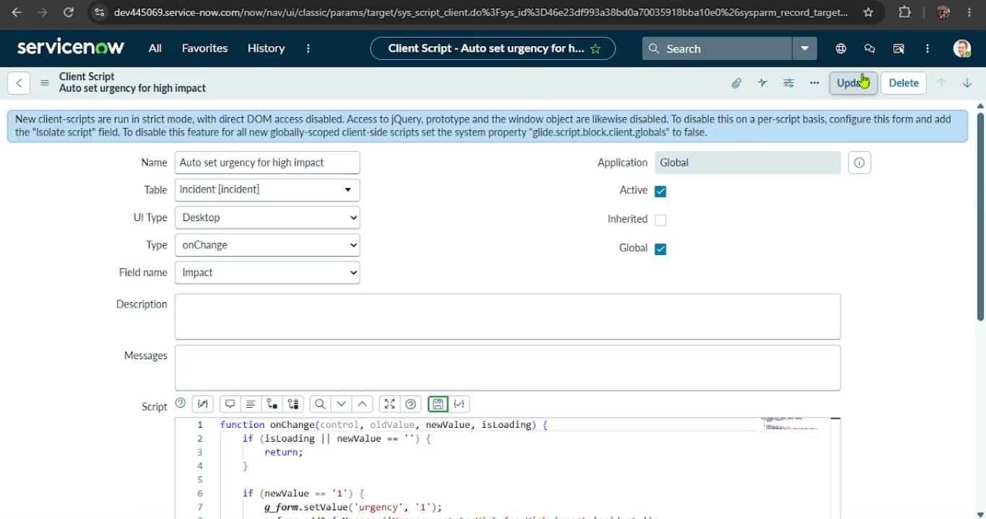
Figure 1: onChange Client Script 'Auto set urgency for high impact' (Field: Impact)
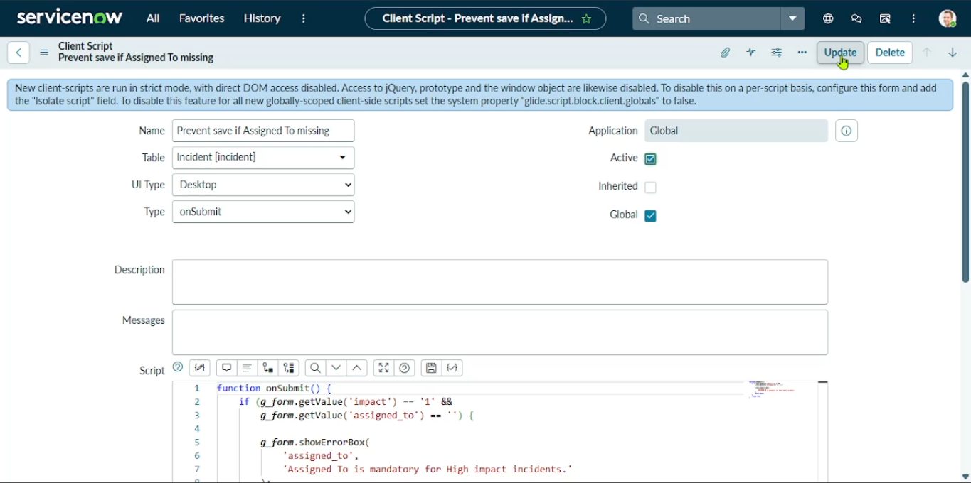
Figure 2: onSubmit Client Script 'Prevent save if Assigned To missing'
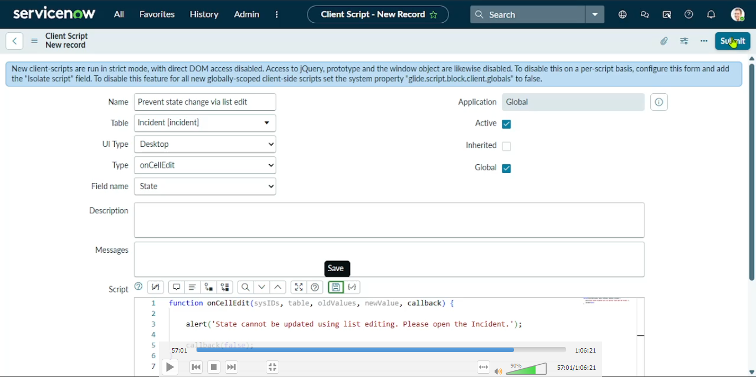
Figure 3: onCellEdit Client Script 'Prevent state change via list edit' (Field: State)
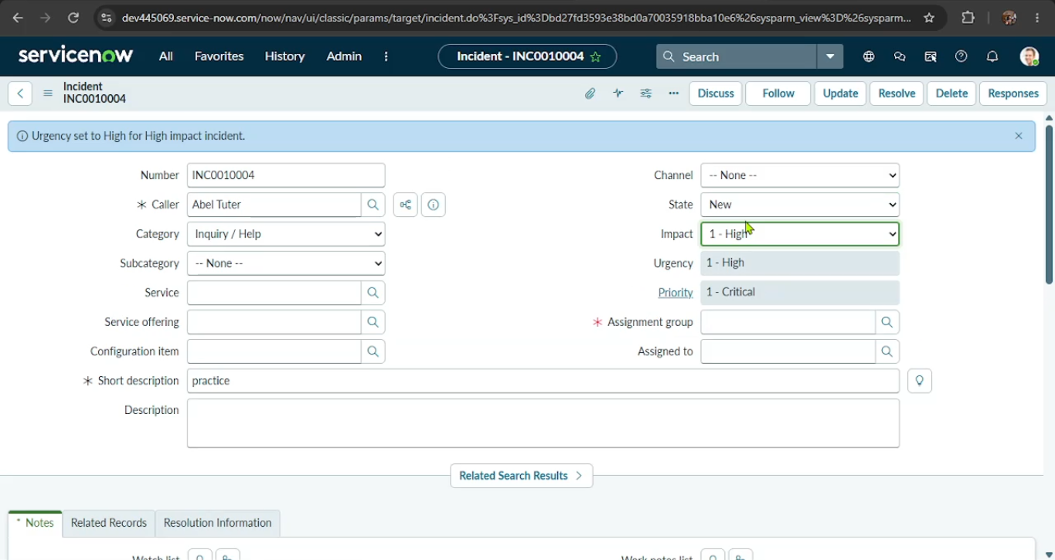
Figure 4: Impact set to High - Urgency auto-set to High (read-only) with info message
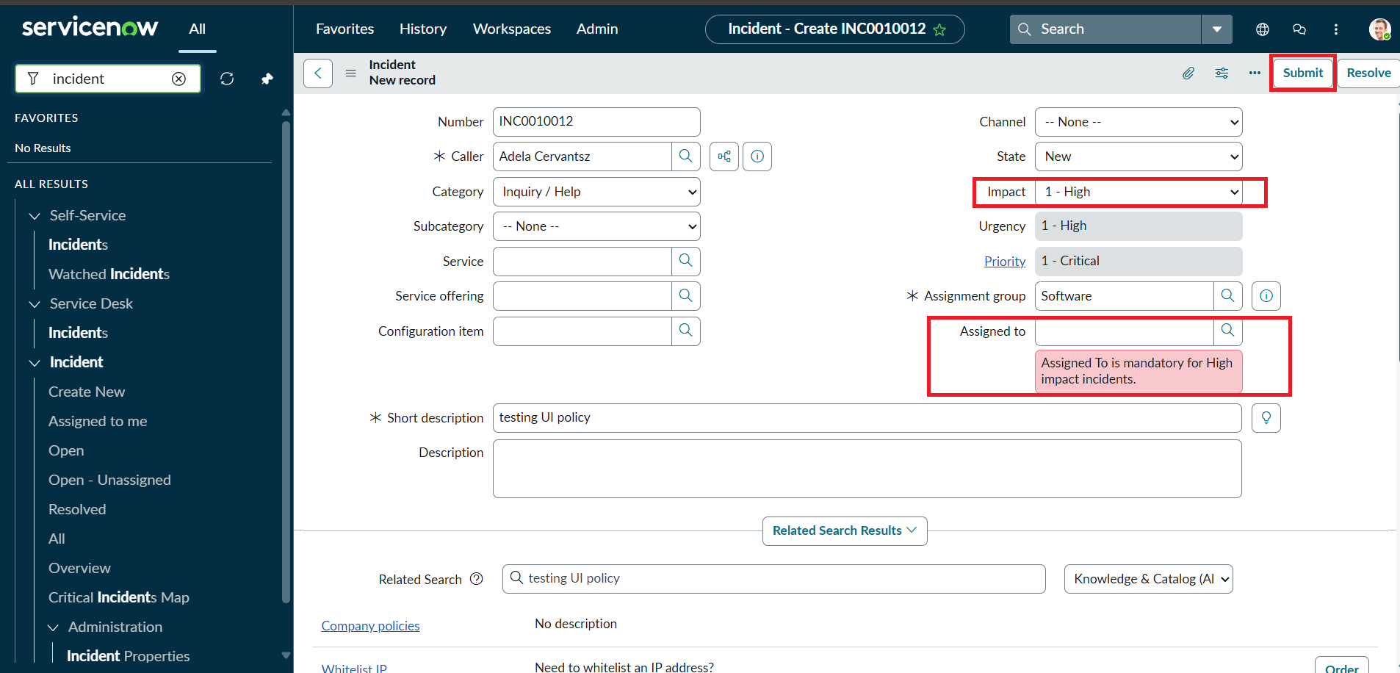
Figure 5: Activity 1 - Save blocked, error 'Assigned To is mandatory for High impact incidents'
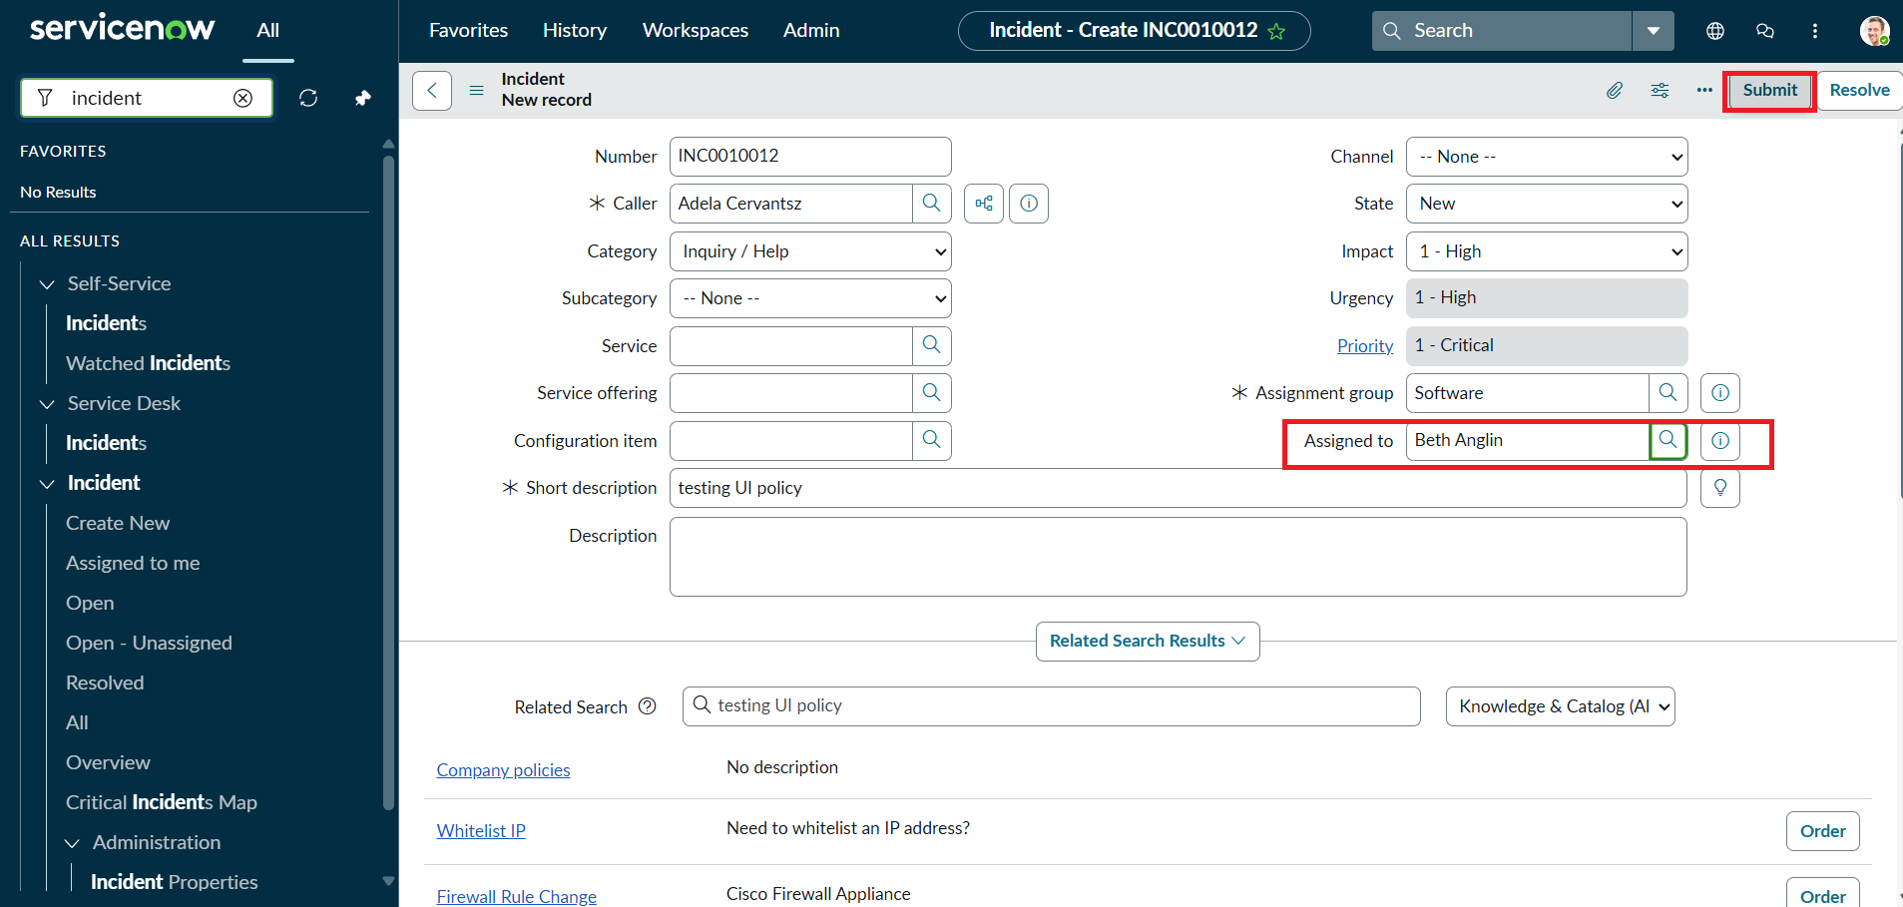
Figure 6: Activity 2 - Assigned To filled, Incident ready to submit successfully
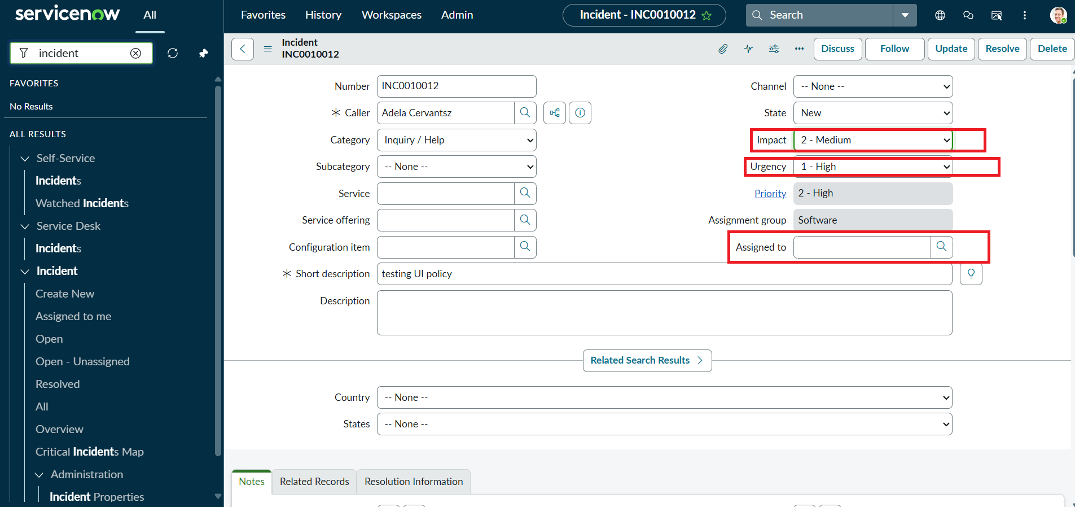
Figure 7: Activity 3 - Impact changed to Medium, Urgency becomes editable (reverse condition)
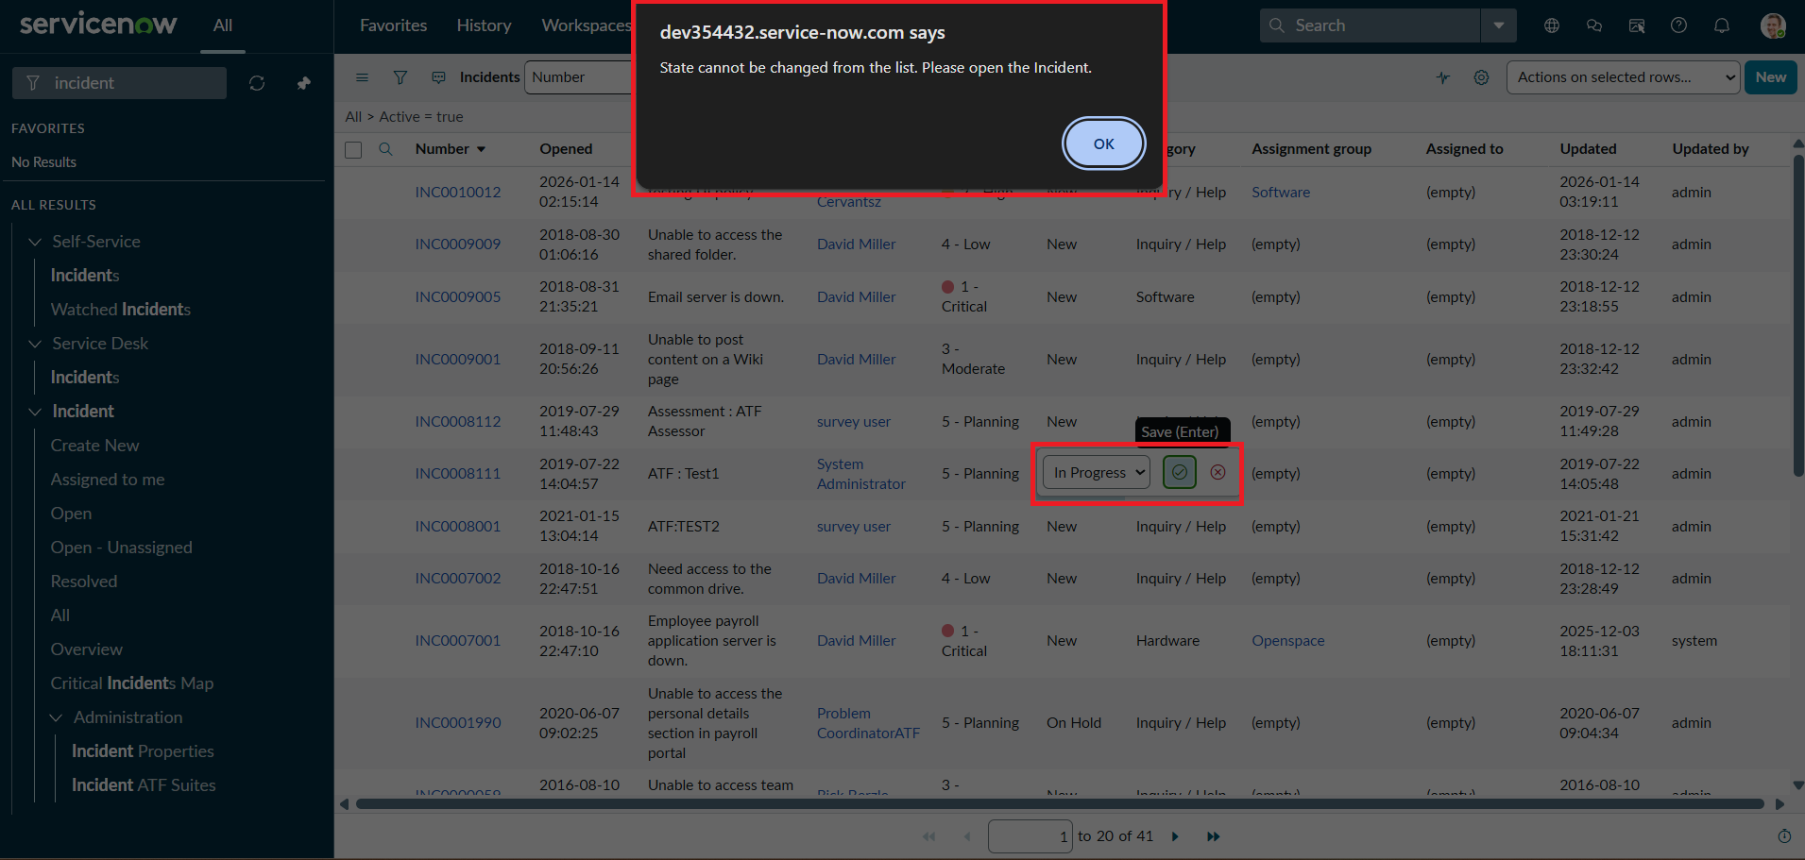
Figure 8: Activity 4 - List view State edit blocked with alert message

8. Advantages & Disadvantages

Advantages
- Ensures every High Impact incident has an owner and correct Urgency
- Protects State field from careless or unauthorized list-view changes
- Real-time validation improves data quality with no custom UI page needed
- Reusable pattern for other Impact/Urgency combinations

Disadvantages
- Client Scripts run in the browser and can be bypassed via direct API/background scripts
- Requires ITIL/admin role knowledge to configure and maintain
- Multiple script types increase maintenance overhead if rules change

9. Conclusion
This project successfully demonstrates the implementation of UI Policies, UI Policy Actions, and Client Scripts on the ServiceNow Incident table. The configuration enables dynamic field behavior, validation, and controlled data entry based on user actions and predefined conditions. By testing different scenarios, the Incident form and list view become more user-friendly, consistent, and reliable, helping improve overall data quality and incident management efficiency.

10. Future Scope
- Extend the High Impact Control pattern to other Impact/Urgency combinations
- Add server-side Business Rules as a backup validation layer to prevent bypass via API
- Integrate with Flow Designer to notify managers of unassigned High Impact incidents
- Apply similar list-edit protection to other critical fields beyond State

11. Appendix

Source Code
onChange Client Script - Auto set urgency for high impact:
function onChange(control, oldValue, newValue, isLoading) { if (isLoading || newValue == '') { return; } if (newValue == '1') { g_form.setValue('urgency', '1'); g_form.addInfoMessage('Urgency set to High for High impact incident.'); } }
onSubmit Client Script - Prevent save if Assigned To missing:
function onSubmit() { if (g_form.getValue('impact') == '1' && g_form.getValue('assigned_to') == '') { g_form.showErrorBox('assigned_to', 'Assigned To is mandatory for High impact incidents.'); return false; } return true; }
onCellEdit Client Script - Prevent state change via list edit:
function onCellEdit(sysIDs, table, oldValues, newValue, callback) { alert('State cannot be updated using list editing. Please open the Incident.'); callback(false); }

Dataset Link
Not applicable - configuration-based project on ServiceNow platform.

GitHub & Project Demo Link
GitHub: https://github.com/raman2662000-cpu/Implement-Client-Script-UI-Policy-Incident-.git
Project Demo Video: https://youtu.be/NlFx9-pgntI

